23lmu21203 - Student 1
1-Watch the video and pick out biographical elements referring to Lionel Rose: sport • people he is compared to • origins • context.

Sport | People he is compared to | Origins | Context

2- Write down what the speakers say about his impact on the nation.

Speaker 1 (host) | Speaker 2 (guest)

3- Identify the contrast the TV host makes between Rose’s childhood and his career.
CAREER

CHILDHOOD

Mise en commun : 23lmu21203 / 23lmu21205
Student 1 and 2 – DOC B and C

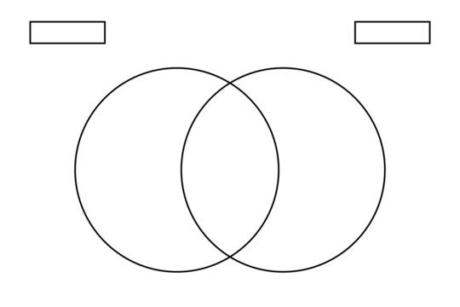
Debate about the athlete who would deserve to be in the Book of records the most and fill out the Venn diagram by following the instructions.

SPECIFICITIES ABOUT CATHY FREEMAN
SPECIFICITIES ABOUT LIONEL ROSE
WHAT THEY HAVE IN COMMON
DOC C
DOC B

