23lmu21205 - Student 2.
Watch the video and pick out as many biographical elements as possible: sport • first medal • origins • dreams as a child • teenage revelation.
Sport | First medal | Origins | Dreams as a child | Teenage revelation

2- Identify the challenges Cathy Freeman had to face, the support she had, and her achievements.
CHALLENGES | SUPPORT | ACHIEVEMENTS

3- Explain how she used the 2000 Olympic Games as a platform to bring about unity in Australia.
_______________________________________________________________________________________________________________________________________________________________________________________________________
Mise en commun : 23lmu21203 / 23lmu21205
Student 1 and 2 – DOC B and C

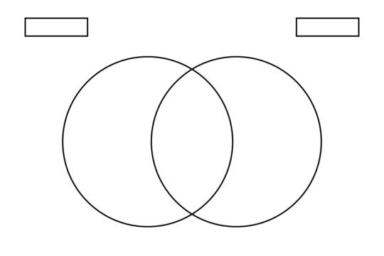
Debate about the athlete who would deserve to be in the Book of records the most and fill out the Venn diagram by following the instructions.

SPECIFICITIES ABOUT CATHY FREEMAN
SPECIFICITIES ABOUT LIONEL ROSE
WHAT THEY HAVE IN COMMON
DOC C
DOC B

