23lmu2207

**Watch the first part of the video (until 0’20”) and take notes: what the statues represent • their name • date • place.**

**ID Card**

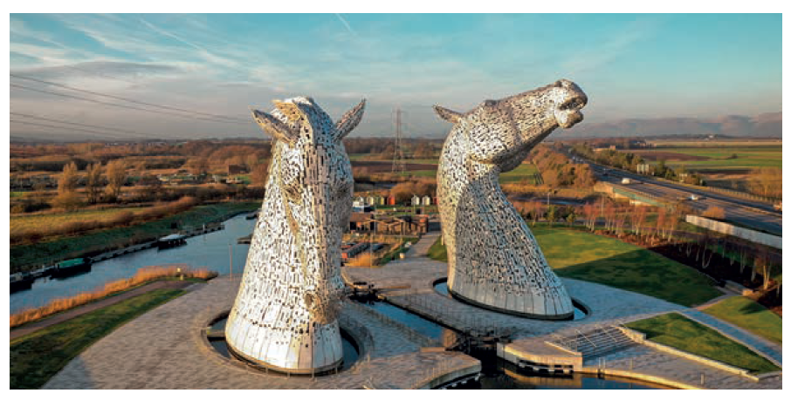

|  |  |
| --- | --- |
| **Name** |  |
| **Date** |  |
| **Place** |  |
| **What they represent / characteristics** |  |

**Watch the second part (0’20** → **end). Recap what Andy Scott’s ambition was when he decided to make these sculptures.**

………………………………………………………………………………………………………………………………………………………………………..………………………………..……………

………………………………………………………………………………………………………………………………………………………………………..………………………………..……………

**List the elements that show the social importance of horses in Scotland.**

………………………………………………………………………………………………………………………………………………………………………..………………………………..……………

………………………………………………………………………………………………………………………………………………………………………..………………………………..……………