Challenge #2 Fiche 2 p. 234
23lmu22105

Watch the picture in your textbook on p. 234, then spot 3 of the items from the following list:
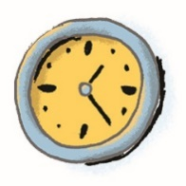  a clock |   a pen |   a fan | 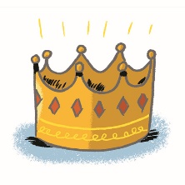  a crown |   a biscuit
  a book | 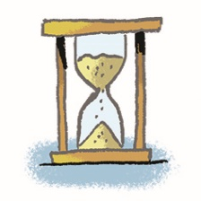  an hourglass | 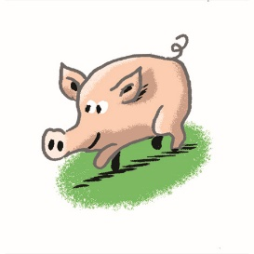  a baby pig | 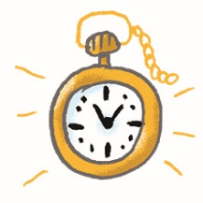  a pocket watch | 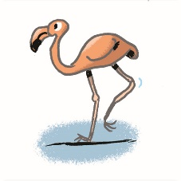  a pink flamingo
The 3 elements are: ………………………………………… ; …………………………….. ; ………………………………….
They all symbolise .

Have you found the solution? Go and see the Game Master and check you have the right answer to escape the rabbit hole.

