Challenge #3 Fiche 3 p. 235
23lmu22106

① Listen to the Caterpillar and Alice’s conversation. Complete the balloons with the phrases / words that keep coming back. Audio 23lmu22107

“I knew who I was this morning, but I think I must have _ _ _ _ _ _ _ several times since then. I’m not _ _ _ _ _ _, you see, and being so many different sizes in one day is very _ _ _ _ _ _ _ _ _.”

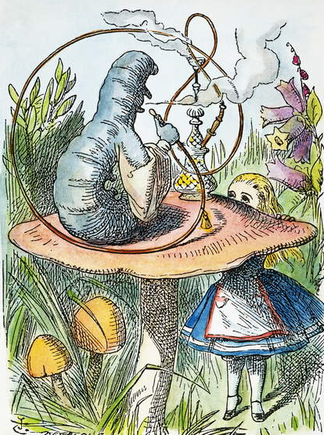

“_ _ _ _ _ _
_ _ _ ?”

From your findings, complete the password with the letters that are in blue.
The password is:

