Challenge #3 Fiche 4 p. 235
23lmu22108

① Use your brain. Reorder the following pictures according to the sequence of events in the extract.

1.  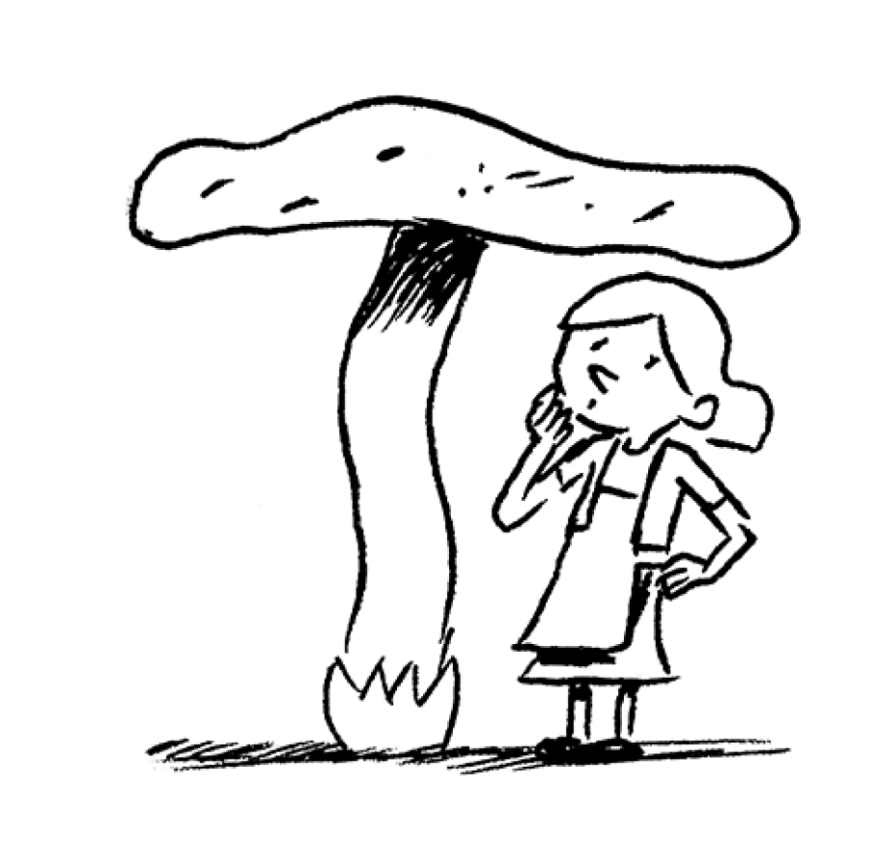 | 2.  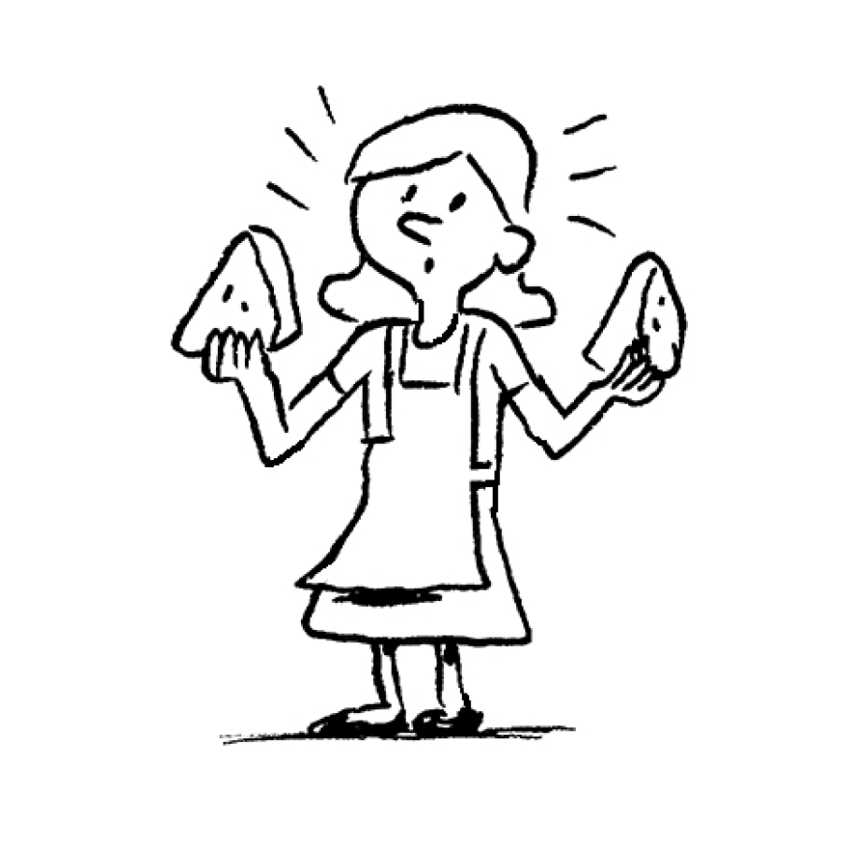 | 3.  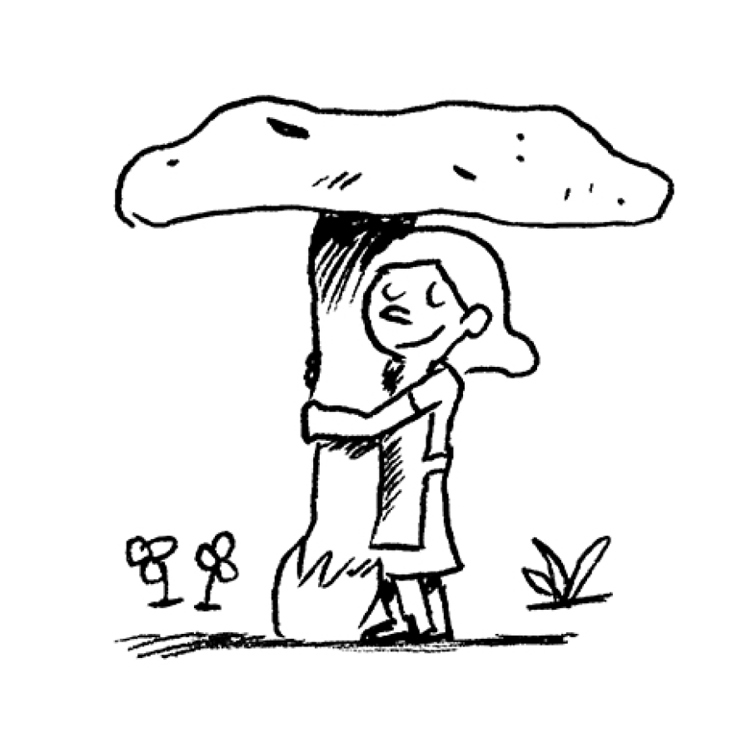 | 4.  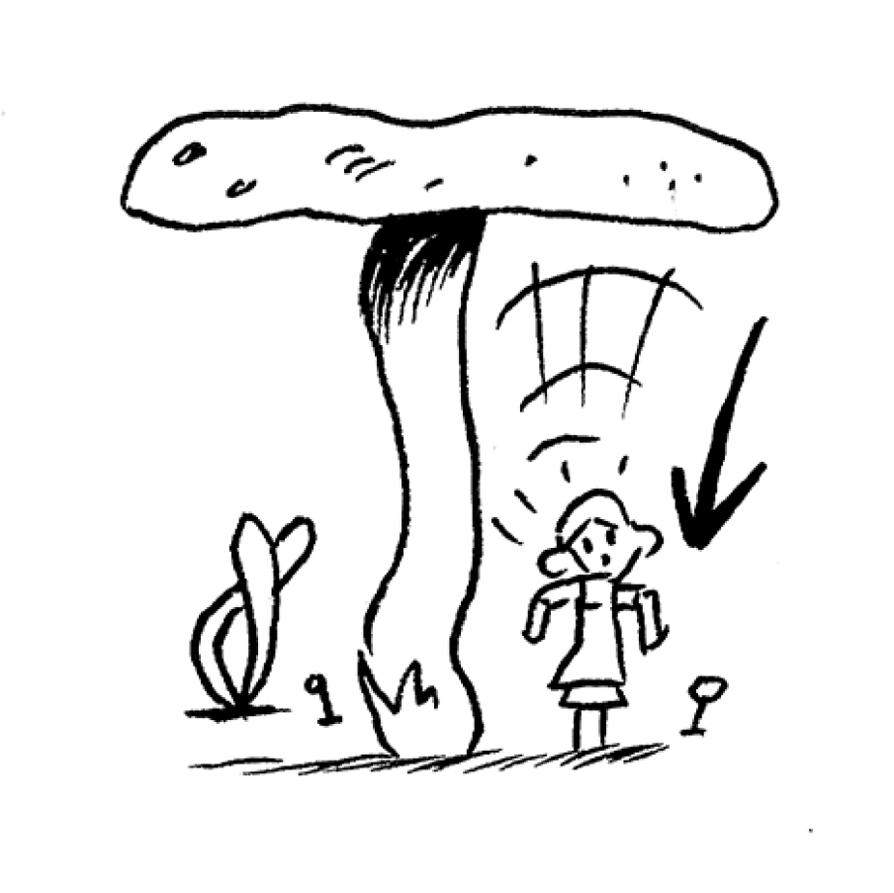
5.  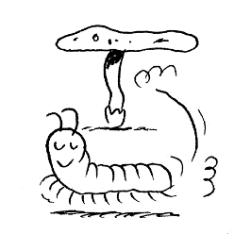 | 6.  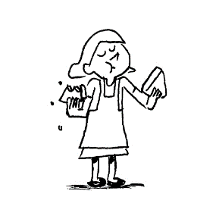 |  | 7.  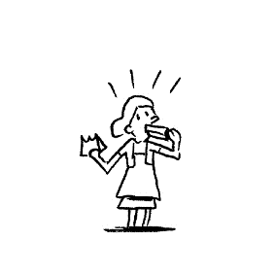

The order of events is:
Now use the code to find out the password:
1 U 6 R
2 E 7 Y
3 B
4 T
5 P
The password is:

Have you found the passwords? Go and bring them to the Game Master.

Now, you are ready for the next meeting!

