# Challenge #6 Fiche 7 **p. 238**

23lmu22113

**① Read the end of the novel in your textbook and reread the poem *A Boat Beneath a Sunny Sky* (down below). Find out the seven key words they have in common.**

**A Boat Beneath a Sunny Sky**

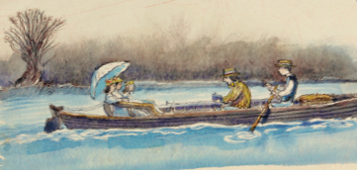

**By Lewis Carroll**

A boat beneath a sunny sky,  
Lingering1 onward dreamily  
In an evening of July —

Children three that nestle2 near,  
Eager eye and willing ear,  
Pleased a simple tale to hear —

Long had paled that sunny sky:  
Echoes fade3 and memories die.  
Autumn frosts have slain July.

Still she haunts me, phantomwise,  
Alice moving under skies  
Never seen by waking eyes.

Children yet, the tale to hear,  
Eager eye and willing ear,  
Lovingly shall nestle near.

In a Wonderland they lie,  
Dreaming as the days go by,  
Dreaming as the summers die:

Ever drifting4 down the stream5 —  
Lingering in the golden gleam6 —  
Life, what is it but a ………..?

1. staying somewhere for a long time - 2. sit in a cosy place - 3. disappear gradually - 4. moving slowly - 5. small river - 6. bright light

**The 7 key words are:**

**eyes; ………..………..………..………..; ………..………..………..………..;**

**………..………..………..………..; ………..………..………..………..; ………..………..………..……….. (s)**

**② Complete the summary with those key words.**

After the pack of cards rose up in the air, Alice opened her **eyes**and realised her journey in

_ _ _ _ _ _ _ _ _ _ was just a _ _ _ _ _ It might then turn into a _ _ _ _ she would be _ _ _ _ _ to tell her future _ _ _ _ _ _ _ _ in _ _ _ _ _ _ when she got older.

**Then use the letters that are in blue to find out the final password, that characterizes the mood of both passages.**

**The feeling is: _ _ _ _ _ _ _ _ _**

## Go and check with the Game Master to get your last piece of Wonderland.