# Fiche 1 **Manuel p. 46**

**Three hours before the President’s speech, hackers blocked the safe in which the Declaration is locked. Security guards are in the Situation Room with the President and do not have time to break the code, you must help them.**

**First step, the Smithsonian Institution in which you will find the first clue to break the code…**

**① Watch the video and identify the different museums and places mentioned.**

Video 23lmu2403

…………..………………………………………………………………………………………………………………………………………………..………………………………………………………………………………………………………………………………………………..………………………………………………………………………………………………………………………………………………..……………………………………………………………………………………………………………………………………

**②** **Complete the ID card of the Smithsonian Institution.**

**Complete the sentence:** It is the ………………………………………………………………………in the world.

**Total number of visitors in 2009:** ………………………………………………..

**Total number of museums and galleries:** ……………………

**What does the number 9 correspond to? …………………**………………………………………………………… **…………………**……………………………………………………………………………………………………………………………

**Total number of objects, artworks and specimens:** ………………………………………………..

**Present in how many states?** ……………………

**Total number of affiliate museums:** ……………………

**Give 4 verbs that correspond to their mission:**

………………………………………………………………………………………………………………………

………………………………………………………………………………………………………………………

**Complete the quote of Joseph Henry, the first secretary of the Smithsonian:**

The…………………… and importance of the ………………………………………… is not to be ………………………………………… by what it ………………………………… within the ……………………………… of its building but by what it …………………………………… forth to the …………………………………

**③ You need to draw your itinerary on the map!**

**a. First, deduce which museums you will have to visit. Use the texts below and the map on the next page.**

The first place you have to go to is where everything started… To go there, you must get off at the Smithsonian subway station. It is surrounded by a garden celebrating victory. It is not far from the Washington Monument, but it is not the African American History and Culture Museum.

__ __ __ __ __ __ __ __ __ __ __ __ __ __ __ __ __ __ __ __ __

To go there, take the subway or rent a bike because it is not in the Mall! In that building you will find two different museums. This is how the one you will visit is described: “The mission of the museum is to tell the story of America by portraying the people who shape the nation’s history, development and culture. Its mission is to display portraits of individuals who have made significant contributions to the history, development, and culture of the people of the United States.”

__ __ __ __ __ __ __ __ __ __ __ __ __ __ __

**A quote from Barack Obama is describing the third museum:**

“The thing about this museum is that it’s more than just telling stories about the famous. It’s not just about the icons. There’s plenty of space for Harriet Tubman and Dr. King and Muhammed Ali. But what makes the museum so powerful and so visceral is that it’s the story of all of us – the folks whose names you never heard of, but whose contributions, day after day, decade after decade, combined to push us forward and the entire nation forward.”

__ __ __ __ __ __ __ __ __ __ __ __ __ __ __ __ __ __ __ __ __ __ __ __ __

__ __ __ __ __ __ __ __ __ __ __ __ __

**Have you identified the 3 museums? Break the enigma thanks to the color code to find where the safe is.**

__ __ __ __ __ __ __

__ __ __ __ __ __ __ _

**b. Now, draw the itinerary on the map.**

**④ Good job! To find the first clue, find how many times the letter “E” is repeated in the password.**

_ _ _

**Write it here: Game Master’s approval:**

# Hackers’ Challenge #1 Fiche 2 **Manuel p. 47**

23lmu2405

**Second step, the Museum of American History in which you will find the second clue to break the code…**

**① Your national anthem is about to be erased in… 3… 2… 1…**

**Listen to the first verse of the anthem and put the sentences back in the correct order.**

Audio 23lmu2412

**② Well done! Note down the number of the sentence in which you can hear the words “*star-spangled banner”*****to find out the next clue.**

**Write the number here: Game Master’s approval:**

_ _ _

|  |  |
| --- | --- |
| **Sentences** | **Correct order**  **(1 to 8)** |
| *And the rocket’s red glare, the bombs bursting in air,* |  |
| *Whose broad stripes and bright stars through the perilous fight* |  |
| *O’er the land of the free and the home of the brave?* |  |
| *O say can you see, by the dawn’s early light,* |  |
| *O say does that star-spangled banner yet wave* |  |
| *Gave proof through the night that our flag was still there,* |  |
| *O’er the ramparts we watch’d, were so gallantly streaming?* |  |
| *What so proudly we hail’d at the twilight’s last gleaming,* |  |

# Hackers’ Challenge #2 Fiche 3 **Manuel p. 47**

23lmu2406

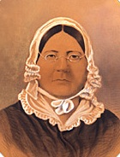**① The hackers want you to listen to Mary Pickersgill’s story. Circle the right answers to their questions to get the third code number.** Audio 23lmu2413

**1. What was Mary Pickersgill asked to do?**

**a)** Have tea with her uncle Henry

**b)** Create a new flag

**c)** Visit Washington DC

**2. Who taught Mary to sew flags?**

**a)** Her mother

**b)** Her daughter

**c)** Major Armistead

**3. Why did she make flags?**

**a)** Because she has always been fascinated by her mother’s work and so decided to do the same thing

**b)** She had no choice, she was forced by the army

**c)**  Because she had no other choice: she had to feed her daughter

**4. Who asked Mary Pickersgill to create a new flag?**

**a)** Major Armistead

**b)** Major Lazer

**c)** George Washington

**5. How would the flag be used?**

**a)** To put on ship when politicians would visit other countries

**b)** To fly above Fort McHenry and to be used in battles

**c)** To decorate the White House

**6. What is special about this flag?**

**a)** It is extremely big

**b)** It is much too small

**c)** It cannot be seen from far away

**7. How did she feel when she was asked to make the flag?**

**a)** Confident and proud

**b)** Depressed and angry

**c)** Extremely happy but then scared

**8. Why are there only 15 stars for 18 American states on the flag?**

**a)** Ohio, Tennessee, and Louisiana refused to be represented

**b)** There was not enough material so they had to sacrifice three states

**c)** Because the last version of the project was adopted before Ohio, Tennessee, and Louisiana became official American states

**9. What are the words that are used to talk about this flag?**

**a)** Shame, disappointment, tyranny

**b)** Bright, shining, marvelous

**c)** Freedom, future, liberty

**10. What’s her daughter’s name?**

**a)** Marylin

**b)** Caroline

**c)** Josephine

**② Well done! Now, let’s find the third number of the code…**

* Note down the letters of the answers in the grid below, then match each letter with the corresponding number (code below).

|  |  |  |  |  |  |  |  |  |  |  |
| --- | --- | --- | --- | --- | --- | --- | --- | --- | --- | --- |
| **Letters** | **Q1: …** | **Q2: …** | **Q3: …** | **Q4: …** | **Q5: …** | **Q6: …** | **Q7: …** | **Q8: …** | **Q9: …** | **Q10: …** |
| **numbers** |  |  |  |  |  |  |  |  |  |  |

a = 1 - b = 2 - c = 3

* Add all the numbers. The total is __ __
* Add these two remaining numbers: __ + __ = __

_ _ _

**Write the number here: Game Master’s approval:**

# Hackers’ Challenge #3 Fiche 4 **Manuel p. 48**

23lmu2409

**Now, you are in the National Portrait Gallery to find more clues…**

**Let’s have some fun… What do you know about the symbols on this famous painting? Watch the video and complete the analysis of the *Lansdowne Portrait*.** Video 23lmu2407

**① Find the three elements discussed in the video and recap what each symbolises. Answer in English!**

|  |  |
| --- | --- |
| **First elements** |  |
| **Second elements** |  |
| **Third** **elements** |  |

**② Got the descriptions? Use your brain to solve the riddle that will allow you to break the fourth part of the code!**

RIDDLE

I am mentioned in one of the three descriptions. I refer to a building that is at the center of the American government. In my heart lies the Senate and the House of Representatives. All the debates are recorded in my JOURNAL.

*Spelling tip: my last letter is repeated twice!*

**ANSWER TO THE RIDDLE:** …………………………………….

**How many letters are there in this word?** __

_ _ _

**Write the number here: Game Master’s approval:**

# Hackers’ Challenge #4 Fiche 5 **Manuel p. 49**

23lmu2409

**① Panic at the National Portrait Gallery: the labels of the Presidents’ portraits have been mixed up by the hackers. Try to complete the text with the proper names.**

**➊** **Thomas …………………….** wrote the Declaration of Independence, founded the University of Virginia, and wrote Virginia’s Statute for Religious Freedom. He was also a philosopher, inventor, gentleman farmer, and scientist. During his presidency, the nation bought a vast land. Known as the Louisiana Purchase, this acquisition from France doubled the size of the United States and led to the remarkable findings of the Lewis and Clark Expedition (1804 - 1806).

**➋** **Abraham …………………….,** one of the greatest challenges as president: preserving the Union. He initially framed the Civil War as a Constitutional crisis over secession, but his aims evolved to include reunification based on the abolition of slavery. In 1865, when the war ended, he proposed a program of Southern reconstruction that would require African American civil rights, but before he could implement it, he was assassinated by John Wilkes Booth.

**➌ Franklin Delano …………………….,** led the United States out of a devastating financial crisis. During his first few months in office, he established the New Deal to save the country. After the United States entered World War II in 1941, he decided to seek a third term, pointing out that one should never change horses in midstream. He helped lay the groundwork for the postwar world. He is the only president to have been elected 4 times (so twice more as authorized by the Constitution).

**➍** Many Americans found it hard to cope with the sudden loss of this youthful, energetic president whose speeches had inspired citizens to achieve high ideals. He was indeed assassinated in 1963. In his shortened tenure as president, **John Fitzgerald …………………….** proposed landmark civil-rights legislation, created the Peace Corps, and promoted the goal of landing on the moon.

**➎ Barack …………………….** made history in 2009 by becoming the first African American president. The former Illinois state senator’s election signaled a feeling of hope for the future even as the U.S. was undergoing its worst financial crisis. Obama enacted the Affordable Care Act, extending health benefits to millions of previously uninsured Americans.

**② Copy the names of the Presidents here to unlock the password.**

President 1: __ __ __ __ __ __ __ __ __

President 2: __ __ __ __ __ __ __

President 3: __ __ __ __ __ __ __ __ __

President 4: __ __ __ __ __ __ __

President 5: __ __ __ __ __

**The password is:** __ __ __ __ __ __ __

* How many vowels are there? __
* How many consonants? __
* Add these two numbers and find the part of the code! __ + __= __

_ _ _

**Write it here: Game Master’s approval:**

# Hackers’ Challenge #5 Fiche 6 **Manuel p. 51**

23lmu2410

**Now, you are in the Museum of African American History and Culture to find more clues.**

**① Read the timeline in your textbook extra carefully then answer the questions below.**

|  |  |  |  |
| --- | --- | --- | --- |
| **Question 1**  **Who was the first African American President elected in 2008?**  **……………………………….** | **Question 2**  **Which prominent Civil Rights activist and peace symbol was killed in Memphis in 1968**?  **……………………………….** | **Question 3**  **In what city did four African American college students launch the first ‘sit-in’ to protest against segregation in 1960?**  **……………………………….** | **Question 4**  **Who signed the Civil Rights Act in 1964?**  **……………………………….**  **……………………………….** |
| **Question 5**  **What is the name of the magazine created by the NAACP in 1909?**  **……………………………….** | **Question 6**  **In 1957, how many students were escorted to school by the US Army?**  ………………………………. | **Question 7**  **What is the name of the case in which the Supreme Court ruled that school segregation was unconstitutional in 1954?**  **……………………………….………………………………….** | |

**② Now use your answers to find and complete the dates on the timeline.**

**③ Well done! Now get the secret number:**

* Add the numbers of the first and last dates: __________ + ____________

= __ __ __ __

* Add the four numbers found: __ + __ + __ + __= __ __
* Do it one more time with the remaining two numbers: __ + __= __

**Write it here:**  **Game Master’s approval:**

_ _ _

# Hackers’ Challenge #6 Fiche 7 **Manuel p. 53**

23lmu2411

**Will you manage to break the code and open the vault in which the *Declaration of Independence* is locked?**

**Complete the password to open the safe with all the numbers**

**you have found before! Check the numbers with the Game Master!**

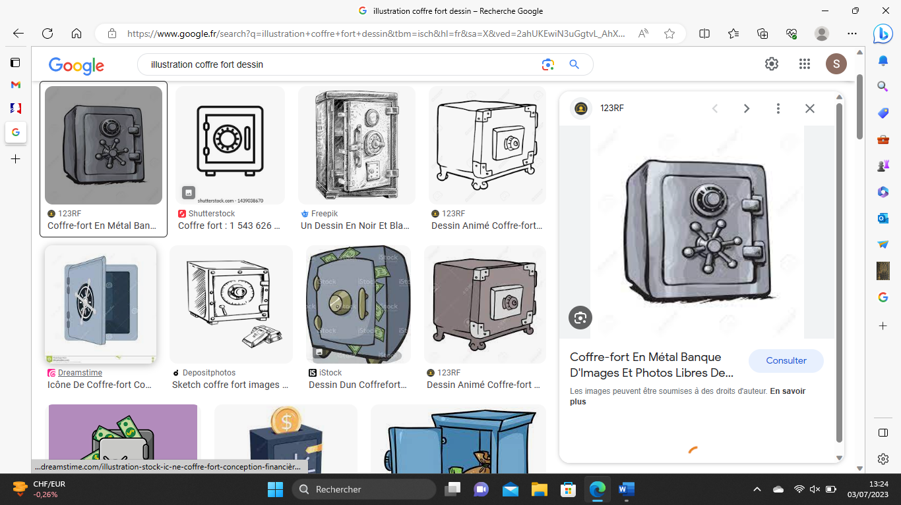

_ _ _ _ _ _

**Game Master’s approval:**

Good job pal! In your honor, the President wants you to read the opening of the declaration to begin the festivities!

*We hold these truths to be self-evident that all men are created equal, that they are endowed by their Creator with certain unalienable Rights, that among these are Life, Liberty and the pursuit of Happiness.*