Fiche 1 p. 46
Three hours before the President’s speech, hackers blocked the safe in which the Declaration is locked. Security guards are in the Situation Room with the President and do not have time to break the code, you must help them.
First step, the Smithsonian Institution in which you will find the first clue to break the code…

① Watch the video and identify the different museums and places mentioned.
Video 23lmu2403
…………..………………………………………………………………………………………………………………………………………………..………………………………………………………………………………………………………………………………………………..………………………………………………………………………………………………………………………………………………..……………………………………………………………………………………………………………………………………
② Complete the ID card of the Smithsonian Institution.
Complete the sentence: It is the ………………………………………………………………………in the world.
Total number of visitors in 2009: ………………………………………………..
Total number of museums and galleries: ……………………
What does the number 9 correspond to? …………………………………………………………………………… ………………………………………………………………………………………………………………………………………………
Total number of objects, artworks and specimens: ………………………………………………..
Present in how many states? ……………………
Total number of affiliate museums: ……………………
Give 4 verbs that correspond to their mission:
………………………………………………………………………………………………………………………
………………………………………………………………………………………………………………………
Complete the quote of Joseph Henry, the first secretary of the Smithsonian:
The…………………… and importance of the ………………………………………… is not to be ………………………………………… by what it ………………………………… within the ……………………………… of its building but by what it …………………………………… forth to the …………………………………

③ You need to draw your itinerary on the map!
a. First, deduce which museums you will have to visit. Use the texts below and the map on the next page.
The first place you have to go to is where everything started… To go there, you must get off at the Smithsonian subway station. It is surrounded by a garden celebrating victory. It is not far from the Washington Monument, but it is not the African American History and Culture Museum.
__ __ __ __ __ __ __ __ __ __ __ __ __ __ __ __ __ __ __ __ __

To go there, take the subway or rent a bike because it is not in the Mall! In that building you will find two different museums. This is how the one you will visit is described: “The mission of the museum is to tell the story of America by portraying the people who shape the nation’s history, development and culture. Its mission is to display portraits of individuals who have made significant contributions to the history, development, and culture of the people of the United States.”
__ __ __ __ __ __ __ __ __ __ __ __ __ __ __

A quote from Barack Obama is describing the third museum:
“The thing about this museum is that it’s more than just telling stories about the famous. It’s not just about the icons. There’s plenty of space for Harriet Tubman and Dr. King and Muhammed Ali. But what makes the museum so powerful and so visceral is that it’s the story of all of us – the folks whose names you never heard of, but whose contributions, day after day, decade after decade, combined to push us forward and the entire nation forward.”
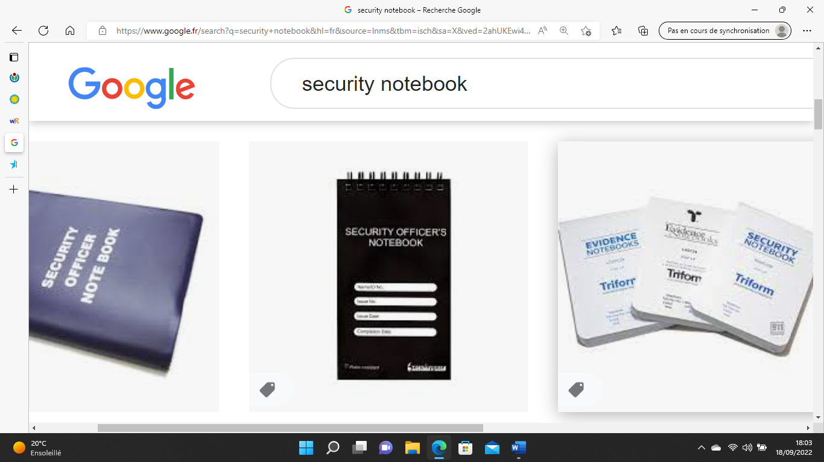
__ __ __ __ __ __ __ __ __ __ __ __ __ __ __ __ __ __ __ __ __ __ __ __ __
__ __ __ __ __ __ __ __ __ __ __ __ __

Have you identified the 3 museums? Break the enigma thanks to the color code to find where the safe is.
__ __ __ __ __ __ __
__ __ __ __ __ __ __ __



b. Now, draw the itinerary on the map.
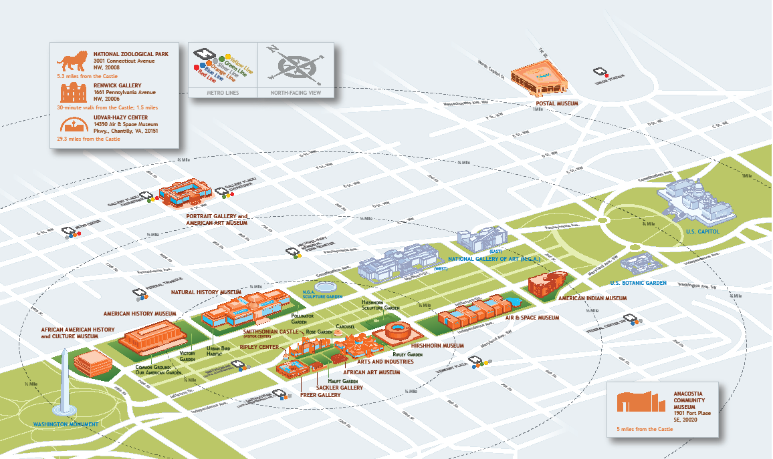
④ Good job! To find the first clue, find how many times the letter "E" is repeated in the password.
_ _ _
Write it here: Game Master’s approval:

