Hackers’ Challenge #3 Fiche 4 Manuel p. 48
23lmu2409
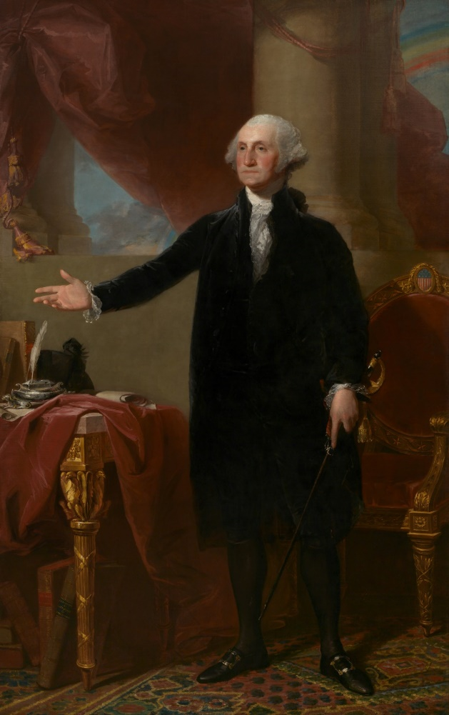
Now, you are in the National Portrait Gallery to find more clues…
Let’s have some fun… What do you know about the symbols on this famous painting? Watch the video and complete the analysis of the Lansdowne Portrait. Video 23lmu2407

① Find the three elements discussed in the video and recap what each symbolises. Answer in English!
First elements
Second elements

Third elements

② Got the descriptions? Use your brain to solve the riddle that will allow you to break the fourth part of the code!
RIDDLE
I am mentioned in one of the three descriptions. I refer to a building that is at the center of the American government. In my heart lies the Senate and the House of Representatives. All the debates are recorded in my JOURNAL.
Spelling tip: my last letter is repeated twice!
ANSWER TO THE RIDDLE: …………………………………….
How many letters are there in this word? __
_ _ _
Write the number here: Game Master’s approval:

