© New Let’s Meet Up 2de – Unit 4 ESCAPE GAME

Hackers’ Challenge #5 Fiche 6 Manuel p. 51
23lmu2410
Now, you are in the Museum of African American History and Culture to find more clues.
① Read the timeline in your textbook extra carefully then answer the questions below.
Question 1  Who was the first African American President elected in 2008?  ………………………………. | Question 2  Which prominent Civil Rights activist and peace symbol was killed in Memphis in 1968?  ………………………………. | Question 3  In what city did four African American college students launch the first ‘sit-in’ to protest against segregation in 1960?  ………………………………. | Question 4  Who signed the Civil Rights Act in 1964?  ……………………………….  ……………………………….
Question 5  What is the name of the magazine created by the NAACP in 1909?  ………………………………. | Question 6  In 1957, how many students were escorted to school by the US Army?  ………………………………. | Question 7  What is the name of the case in which the Supreme Court ruled that school segregation was unconstitutional in 1954?  ……………………………….………………………………….
② Now use your answers to find and complete the dates on the timeline.
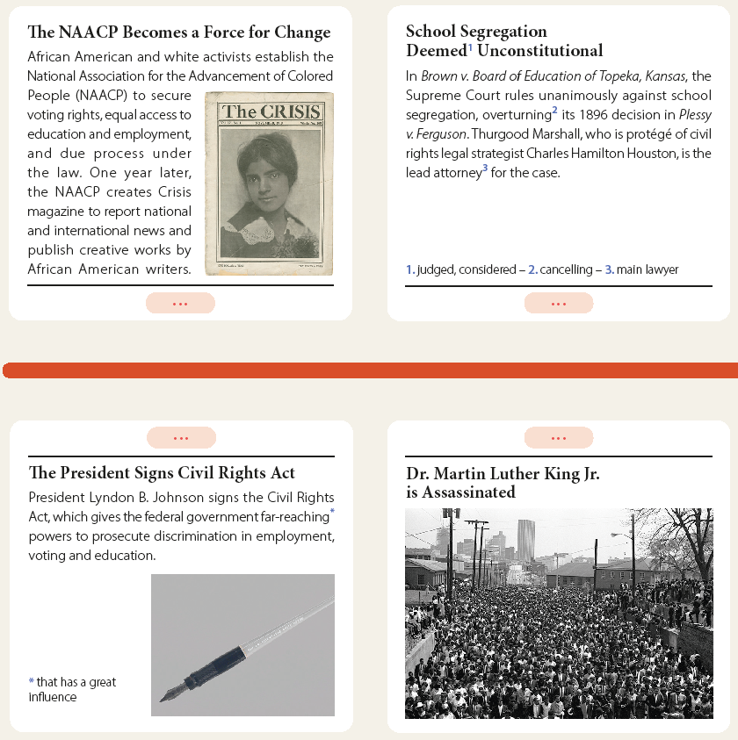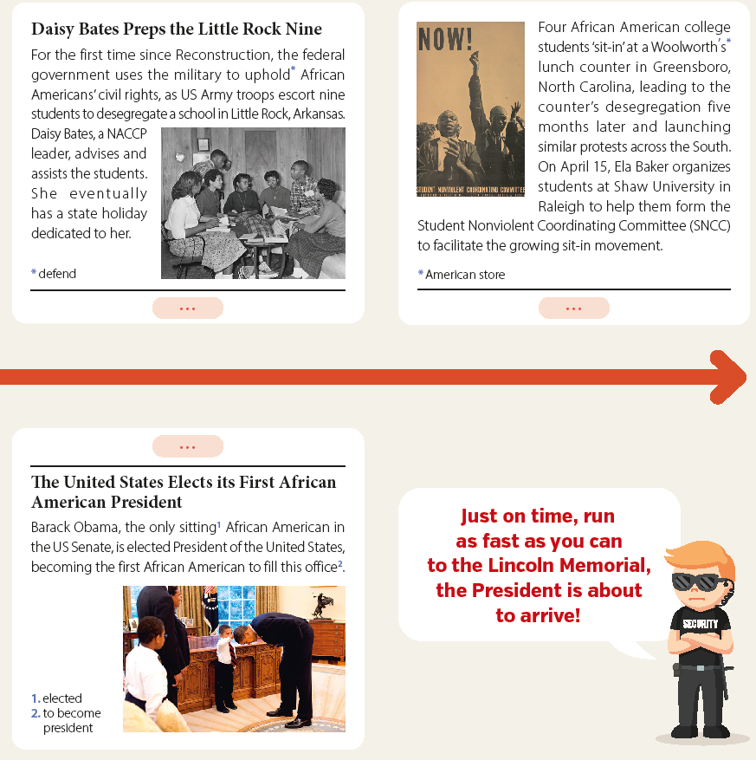
③ Well done! Now get the secret number:
- Add the numbers of the first and last dates: __________ + ____________
= __ __ __ __
- Add the four numbers found: __ + __ + __ + __= __ __
- Do it one more time with the remaining two numbers: __ + __= __
Write it here: Game Master’s approval:
_ _ _

