# Hackers’ Challenge #6 Fiche 7 **Manuel p. 53**

23lmu2411

**Will you manage to break the code and open the vault in which the *Declaration of Independence* is locked?**

**Complete the password to open the safe with all the numbers**

**you have found before! Check the numbers with the Game Master!**

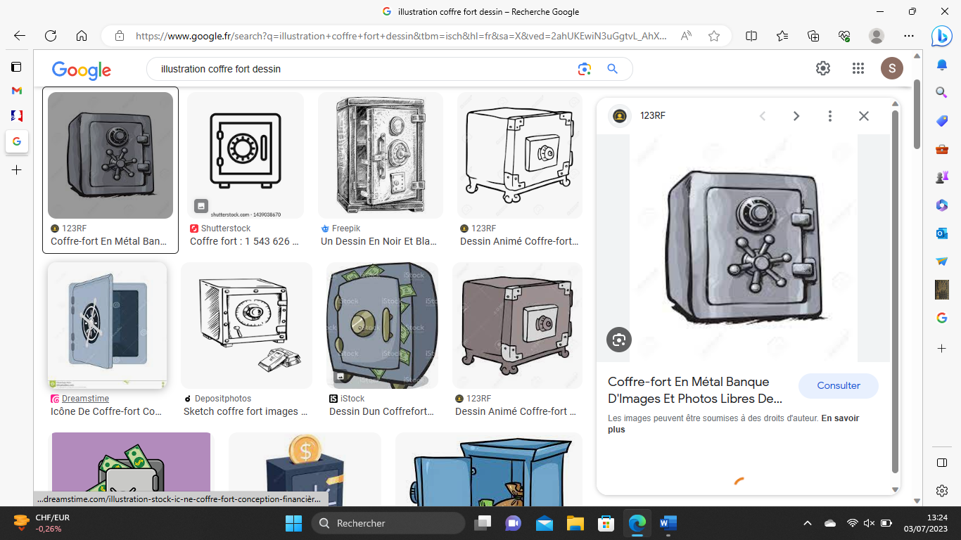

_ _ _ _ _ _

**Game Master’s approval:**

Good job pal! In your honor, the President wants you to read the opening of the declaration to begin the festivities!

*We hold these truths to be self-evident that all men are created equal, that they are endowed by their Creator with certain unalienable Rights, that among these are Life, Liberty and the pursuit of Happiness.*