

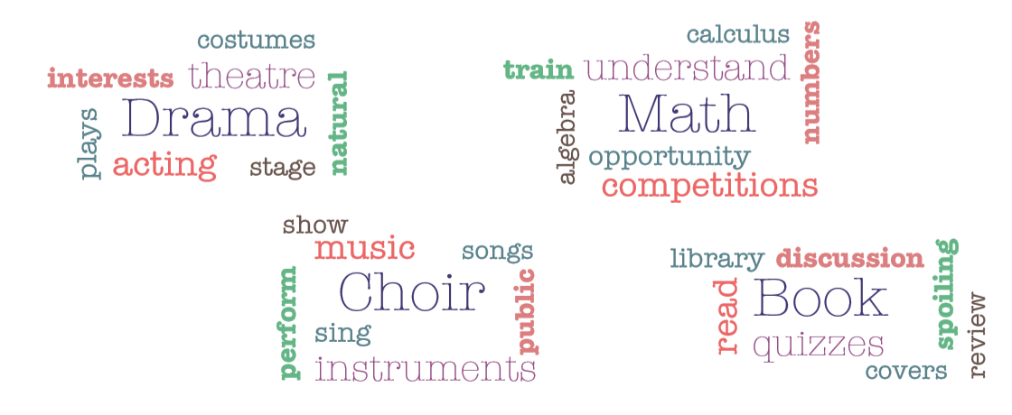

**1.** Write down the words you hear for each club. You can also circle them in the word cloud!

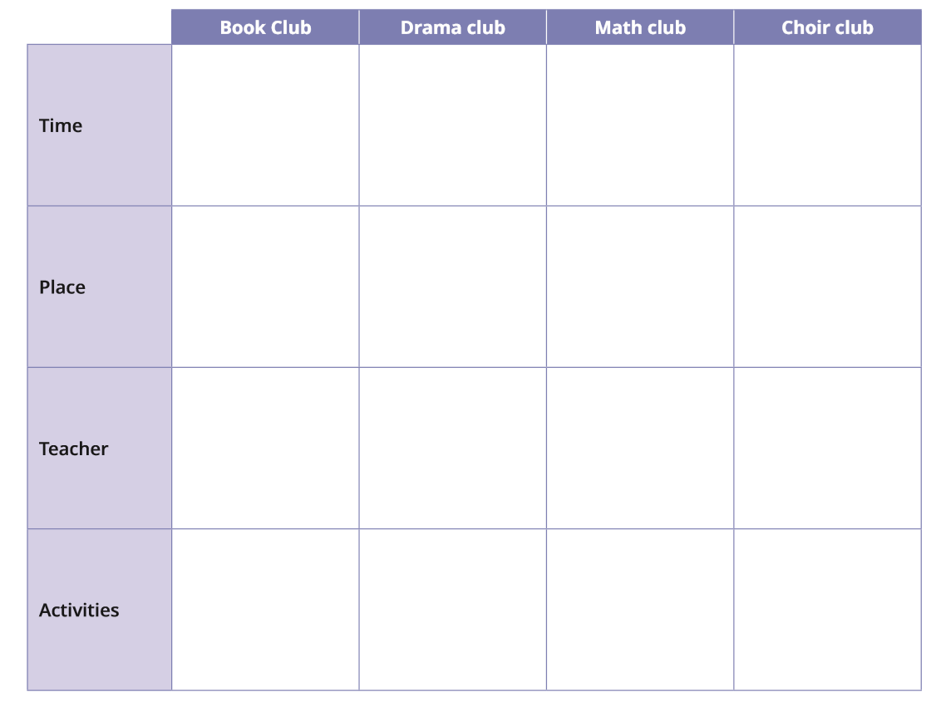

**2.** Watch the video again and note down extra words you can hear.

……………………………………………………………………………………………………………

……………………………………………………………………………………………………………

……………………………………………………………………………………………………………

……………………………………………………………………………………………………………

**3.** Write a short description of the drama club and the book club.

**a.** Drama club:

**b.** Book club:

**4.** Let’s practise! You are the president of the film club at the British School of Paris. Present the club.

……………………………………………………………………………………………………………

……………………………………………………………………………………………………………

……………………………………………………………………………………………………………

……………………………………………………………………………………………………………

……………………………………………………………………………………………………………

……………………………………………………………………………………………………………

……………………………………………………………………………………………………………

……………………………………………………………………………………………………………

……………………………………………………………………………………………………………

……………………………………………………………………………………………………………

……………………………………………………………………………………………………………

……………………………………………………………………………………………………………