hatier-clic.fr/lmu1144 En entier.

Prepare the viewing
1. Look at the pictures (1-6) then put the correct caption (A-F) under the corresponding screenshot.
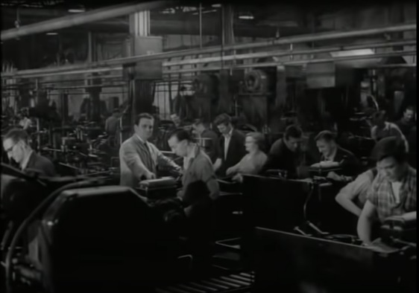  1 | 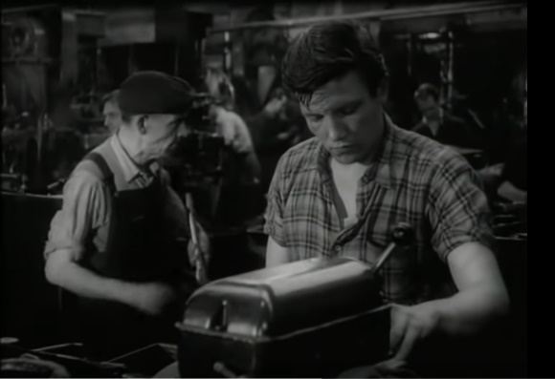  2
3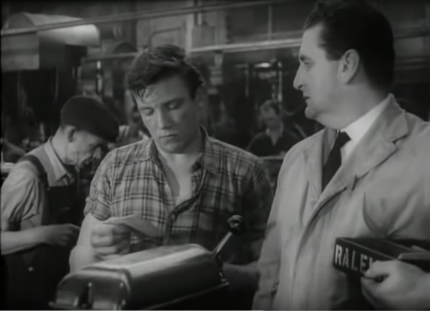 | 4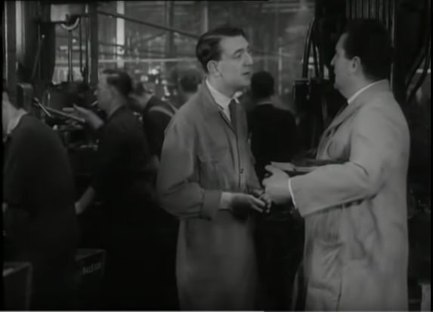
5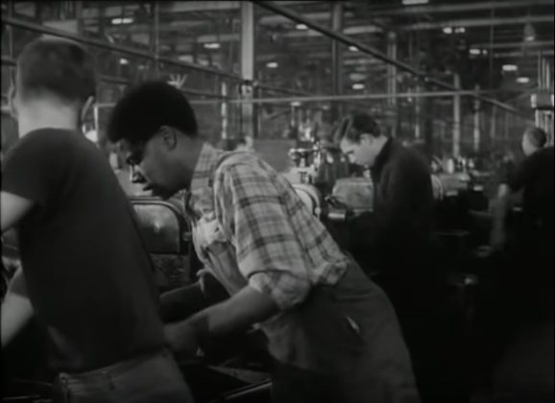 | 6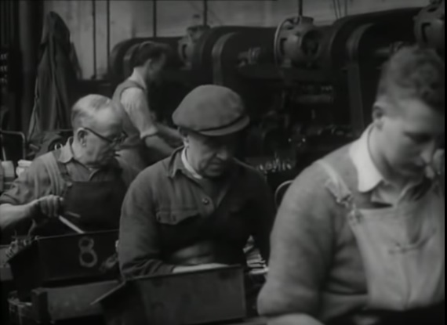

A. Three workers are working, one behind the other.
B. Arthur, a young machinist, manufactures thousands of bicycle parts.
C. He is receiving his wage from Robboe, his supervisor and he is checking the amount.
D. Men are working in a factory while the supervisor is watching them.
E. Fred, a colleague, is working on his machine.
F. Jack, a colleague, and Robboe are talking.

2. Match the synonyms using a dictionary if necessary.
lot /lɒt/ ⃝ |  | ⃝ full
bloody /blʌdi/ ⃝ |  | ⃝ disinformation
slash /slæʃ/ ⃝ |  | ⃝ belly
fag (slang)/fæɡ/ ⃝ |  | ⃝ cigarette
stuffed /stʌft/ ⃝ |  | ⃝ damn
gut /ɡʌt/ ⃝ |  | ⃝ prize
propaganda /prɒpəɡændə/ ⃝ |  | ⃝ reduce

3. Find out what the following verbal expressions mean in French.
have a bad back: ……………………………………………………………………………………
get on: ……………………………………………………………………………………………….
grind someone down: ………………………………………………………………………………
get over something: ………………………………………………………………………………...

Watch the video
4. Use your strategies and take notes. Give your impressions.
5. Get ready for class! Choose five words to introduce the document.
1. …………..………….. | 2. …………..………….. | 3. …………..………….. | 4. …………..………….. | 5. …………..…………..

